
1. IPSec Authentication Header (AH) – MAC Generation and Verification
Aim
To simulate the IPSec Authentication Header (AH) process by generating and verifying a Message Authentication Code (MAC) for ensuring IP packet integrity.
Algorithm
- Read the IP packet data.
- Enter a secret key shared between sender and receiver.
- Generate a MAC using HMAC-SHA256.
- Attach the MAC with the packet.
- At the receiver side, calculate the MAC again using the same key.
- Compare the received MAC with the calculated MAC.
- If both are equal, the packet is authentic and has not been modified.
- Otherwise, report that the packet has been modified.
Python Program
import hmac
import hashlib

def generate_mac(packet, key):
return hmac.new(
key.encode(),
packet.encode(),
hashlib.sha256
).hexdigest()

# Sender
packet = input("Enter IP packet data: ")
key = input("Enter secret key: ")

mac = generate_mac(packet, key)

print("\n--- Sender ---")
print("IP Packet:", packet)
print("Generated MAC:", mac)

# Receiver
received_packet = input("\nEnter received packet: ")

received_mac = generate_mac(received_packet, key)

print("\n--- Receiver ---")
print("Calculated MAC:", received_mac)

if hmac.compare_digest(mac, received_mac):
print("Authentication Successful")
print("Packet Integrity Verified")
else:
print("Authentication Failed")
print("Packet has been modified")
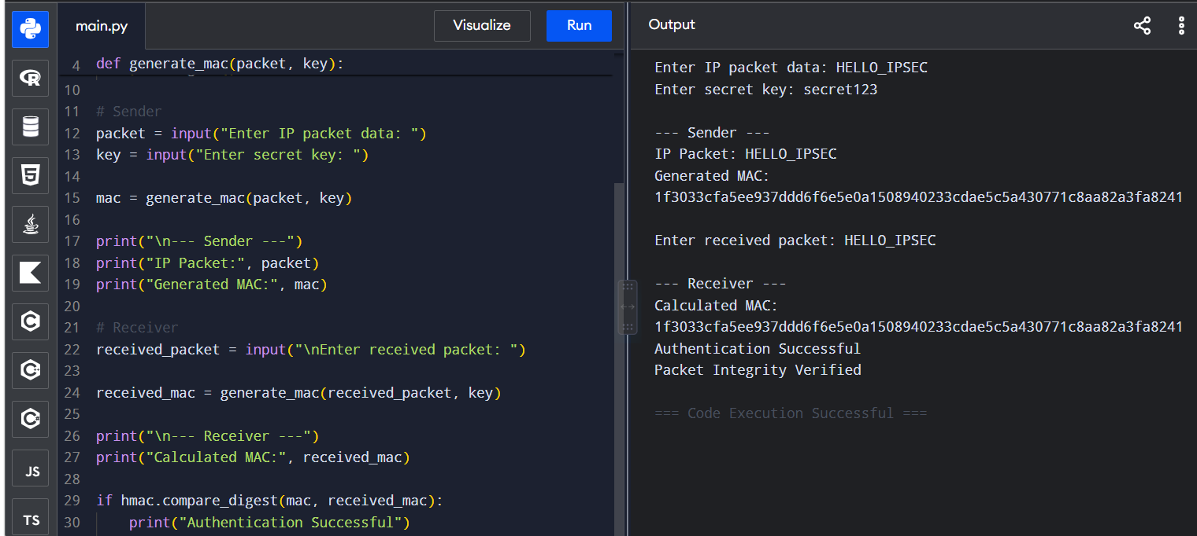
Output
Result
Thus, the IPSec AH process was successfully simulated using HMAC-SHA256 to verify IP packet integrity.

2. IPSec ESP – Encryption and Decryption
Aim
To implement a simplified Encapsulating Security Payload (ESP) process for encrypting and decrypting IP packet payloads.
Algorithm
- Read the IP packet payload.
- Generate an encryption key.
- Encrypt the payload using a symmetric encryption technique.
- Display the encrypted payload.
- At the receiver, decrypt the encrypted payload using the same key.
- Display the original payload.
- Verify that the decrypted data matches the original data.
Python Program
from cryptography.fernet import Fernet

# Generate encryption key
key = Fernet.generate_key()
cipher = Fernet(key)

# Sender
payload = input("Enter IP packet payload: ")

encrypted_data = cipher.encrypt(payload.encode())

print("\n--- ESP Sender ---")
print("Original Payload:", payload)
print("Encrypted Payload:", encrypted_data.decode())

# Receiver
decrypted_data = cipher.decrypt(encrypted_data)

print("\n--- ESP Receiver ---")
print("Decrypted Payload:", decrypted_data.decode())

if decrypted_data.decode() == payload:
print("Decryption Successful")
else:
print("Decryption Failed")
Output 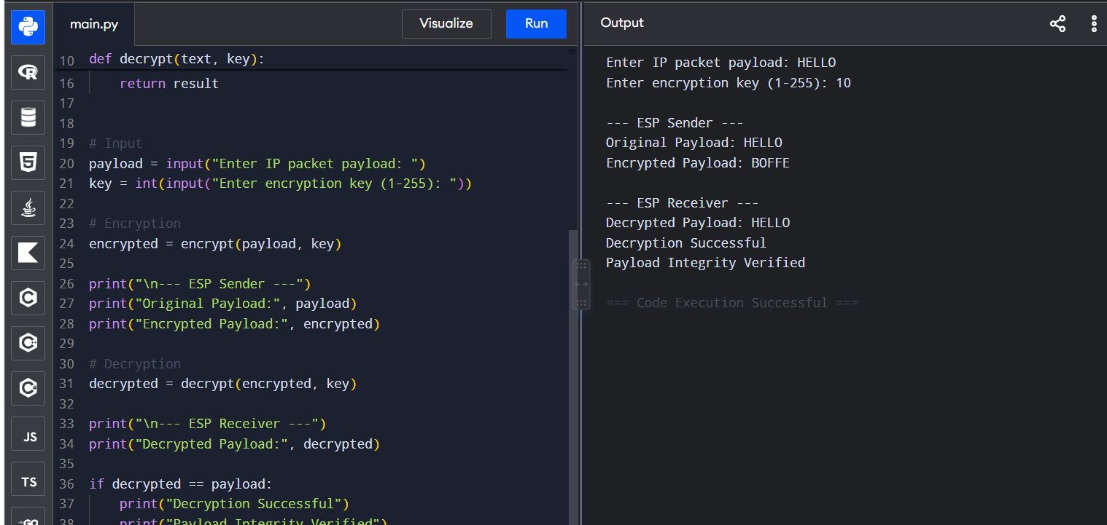

Result
Thus, a simplified IPSec ESP mechanism was successfully implemented for encryption and decryption of IP packet payloads.
Note: Install the library if required:
pip install cryptography

3. IPSec Security Association (SA) Management
Aim
To design a program for managing Security Associations (SA) in IPSec, including creation, lookup, and deletion operations.
Algorithm
- Create an empty Security Association database.
- Provide options to:
  - Create an SA
  - Look up an SA
  - Delete an SA
  - Display all SAs
- For creation, store SPI, source IP, destination IP, protocol and encryption algorithm.
- For lookup, search using the SPI.
- For deletion, remove the SA associated with the given SPI.
- Display the appropriate result.
Python Program
SA_DATABASE = {}

def create_sa():
spi = input("Enter SPI: ")
src = input("Enter Source IP: ")
dst = input("Enter Destination IP: ")
protocol = input("Enter Protocol (AH/ESP): ")
algorithm = input("Enter Encryption Algorithm: ")

SA_DATABASE[spi] = {
"Source IP": src,
"Destination IP": dst,
"Protocol": protocol,
"Algorithm": algorithm
}

print("Security Association created successfully.")

def lookup_sa():
spi = input("Enter SPI to lookup: ")

if spi in SA_DATABASE:
print("\nSecurity Association Found:")
print(SA_DATABASE[spi])
else:
print("Security Association not found.")

def delete_sa():
spi = input("Enter SPI to delete: ")

if spi in SA_DATABASE:
del SA_DATABASE[spi]
print("Security Association deleted successfully.")
else:
print("Security Association not found.")

def display_sa():
print("\n--- Security Association Database ---")

if not SA_DATABASE:
print("No Security Associations available.")
else:
for spi, details in SA_DATABASE.items():
print("SPI:", spi)
print(details)

while True:
print("\n1. Create SA")
print("2. Lookup SA")
print("3. Delete SA")
print("4. Display All SA")
print("5. Exit")

choice = input("Enter your choice: ")

if choice == "1":
create_sa()
elif choice == "2":
lookup_sa()
elif choice == "3":
delete_sa()
elif choice == "4":
display_sa()
elif choice == "5":
print("Program terminated.")
break
else:
print("Invalid choice.")
Output
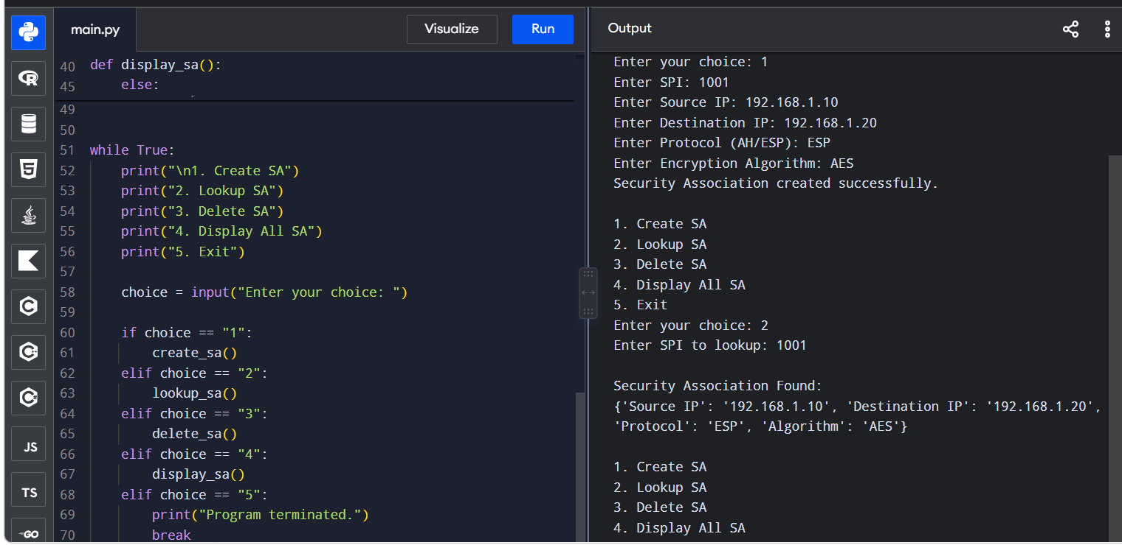

Result
Thus, Security Association creation, lookup and deletion operations were successfully implemented.

4. Simplified PGP System
Aim
To implement a simplified Pretty Good Privacy (PGP) system using public key encryption and digital signatures for secure email communication.
Algorithm
- Generate a public-private key pair.
- Create the email message.
- Generate a digital signature using the sender's private key.
- Encrypt the message using the receiver's public key.
- Send the encrypted message and signature.
- Receiver decrypts the message using the receiver's private key.
- Verify the digital signature using the sender's public key.
- Display whether the message is authentic.
Python Program
from cryptography.hazmat.primitives.asymmetric import rsa, padding
from cryptography.hazmat.primitives import hashes

# Generate sender keys
sender_private_key = rsa.generate_private_key(
public_exponent=65537,
key_size=2048
)

sender_public_key = sender_private_key.public_key()

# Generate receiver keys
receiver_private_key = rsa.generate_private_key(
public_exponent=65537,
key_size=2048
)

receiver_public_key = receiver_private_key.public_key()

# Email message
message = input("Enter email message: ").encode()

# Digital Signature
signature = sender_private_key.sign(
message,
padding.PSS(
mgf=padding.MGF1(hashes.SHA256()),
salt_length=padding.PSS.MAX_LENGTH
),
hashes.SHA256()
)

# Encrypt message using receiver's public key
encrypted_message = receiver_public_key.encrypt(
message,
padding.OAEP(
mgf=padding.MGF1(hashes.SHA256()),
algorithm=hashes.SHA256(),
label=None
)
)

print("\n--- Sender ---")
print("Message encrypted successfully.")
print("Digital signature generated.")

# Receiver decrypts
decrypted_message = receiver_private_key.decrypt(
encrypted_message,
padding.OAEP(
mgf=padding.MGF1(hashes.SHA256()),
algorithm=hashes.SHA256(),
label=None
)
)

# Verify signature
try:
sender_public_key.verify(
signature,
decrypted_message,
padding.PSS(
mgf=padding.MGF1(hashes.SHA256()),
salt_length=padding.PSS.MAX_LENGTH
),
hashes.SHA256()
)

print("\n--- Receiver ---")
print("Decrypted Message:", decrypted_message.decode())
print("Digital Signature: VALID")
print("PGP Verification Successful")

except:
print("Digital Signature: INVALID")

Output
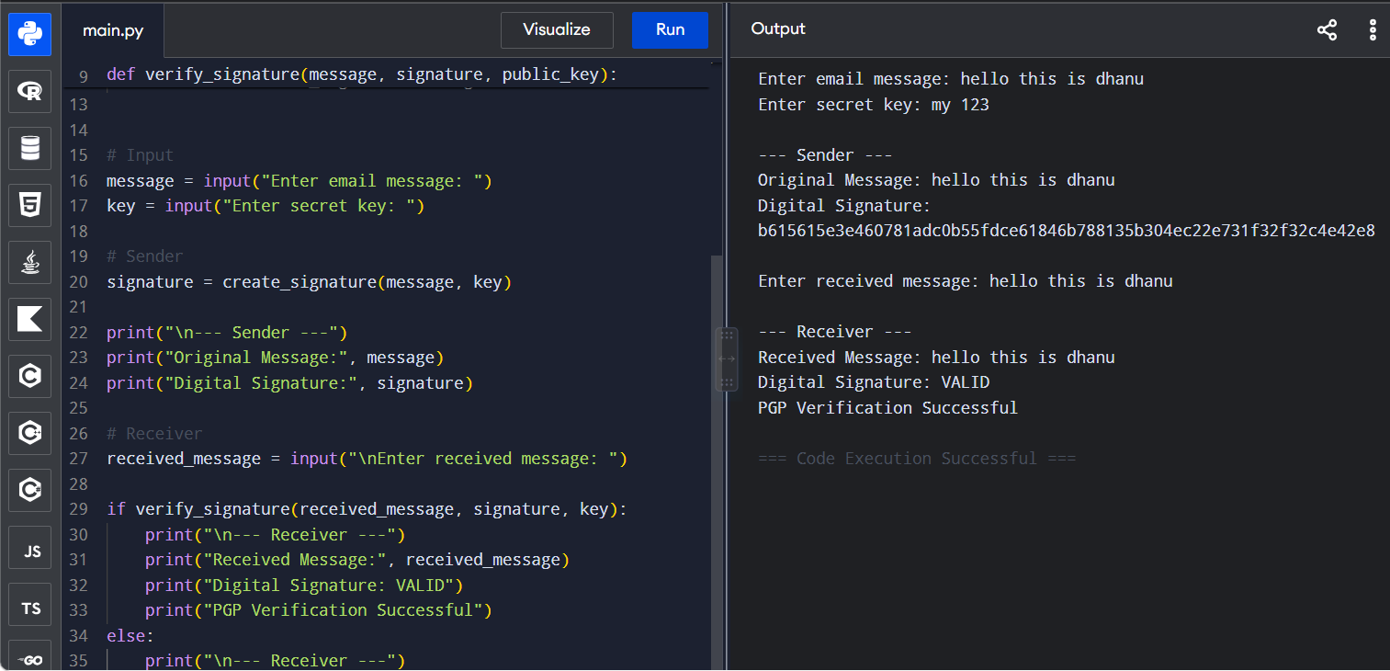

Result
Thus, a simplified PGP system was successfully implemented using public-key encryption and digital signatures for secure email communication.

5. Email Spam Classification
Aim
To create a program that classifies emails as spam or legitimate using email header analysis and content-based filtering techniques.
Algorithm
- Read the email sender, subject and message content.
- Define common spam keywords.
- Check the sender and subject for suspicious patterns.
- Search the email body for spam-related keywords.
- Assign a spam score based on the number of suspicious features.
- If the score exceeds the threshold, classify the email as spam.
- Otherwise, classify it as legitimate.

Python Program
def classify_email(sender, subject, body):

spam_words = [
"free",
"winner",
"win",
"prize",
"offer",
"urgent",
"click here",
"money",
"lottery",
"claim"
]

score = 0

text = (sender + " " + subject + " " + body).lower()

# Content-based filtering
for word in spam_words:
if word in text:
score += 1

# Header analysis
if "noreply" in sender.lower():
score += 1

if "urgent" in subject.lower():
score += 2

if score >= 3:
return "SPAM", score
else:
return "LEGITIMATE", score

sender = input("Enter sender email: ")
subject = input("Enter email subject: ")
body = input("Enter email content: ")

result, score = classify_email(sender, subject, body)

print("\n--- Email Classification ---")
print("Sender:", sender)
print("Subject:", subject)
print("Spam Score:", score)
print("Classification:", result)
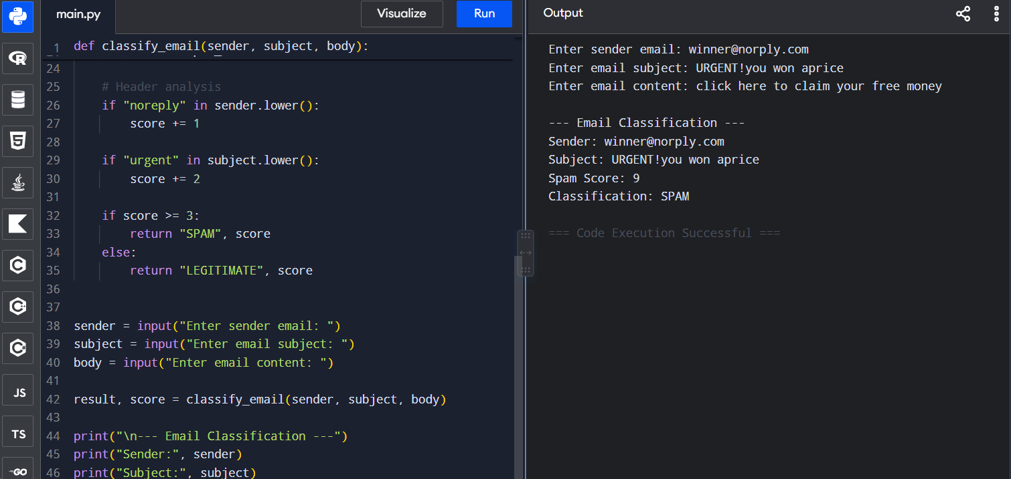
Sample Output
Result
Thus, an email classification system was successfully implemented using email header analysis and content-based filtering to identify spam and legitimate emails.

